RFP No.2023-1 – Request for Coud-Based Accounting System
EARLYLEARNING COALITION OF ESCAMBIA COUNTY

It is hereby announced on December 14, 2023, The Board of Directors of The Early
Learning Coalition of Escambia County (ELCEC) has elected to award the Cloud Based Accounting System contract to Community Brands MIP Fund Accounting.
Any person who is adversely affected by the decision shall submit a formal written protest within three (3) business days after this electronic posting of the Notice of Award to the Executive Director of the ELCEC, describing, in detail, the nature of the protest/dispute.
Attn: Executive Director
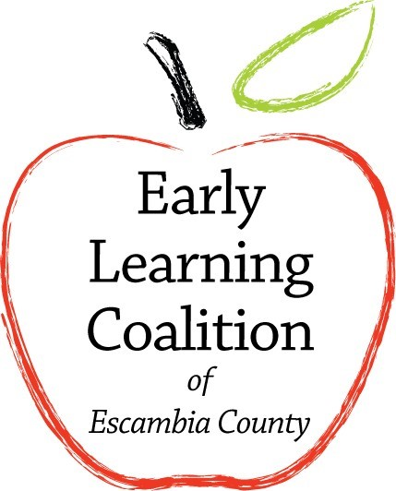
Early Learning Coalition of Escambia County
1720
W Fairfield Drive

Suite 100/400
Pensacola
, FL
32501

Office: (850)
332
-
7847

Fax: (850)
466
-
3783

Notice o
f Intent to Award

1720 W Fairfield Drive Ste 100/400
Pensacola, FL 32501
The Executive Director will review the appeal and respond in writing within three (3) business days from the date of receipt of the formal written request. Should the Executive Director require additional time to review the matter, the Offeror shall be advised in writing (electronic and/or by mail) within five (5) business day period.
In the event the Executive Director's response is not satisfactory to the Offeror, an appeal to the Board of Directors may be requested. The appeal must be provided in writing within five (5) calendar days from receipt of the response from the ELCEC and address it to:
Attn: Board Chair
Early Learning Coalition of Escambia County
1720 W Fairfield Drive Ste 100/400
Pensacola, FL 32501

Thank you to all the Vendors for participating in the competitive selection process.

